**Chronostasis** by T.S. Stephens

Sensation and perception work together, but are different. In psychology, sensation and perception are stages of processing of the senses, such as vision, auditory, vestibular, and pain senses. One can sense lights, but one perceives that this is a truck headed down the highway. Perception is an amazing and difficult to study area of human experience. Optical and visual illusions are among favorites. Do people perceive the same thing differently?

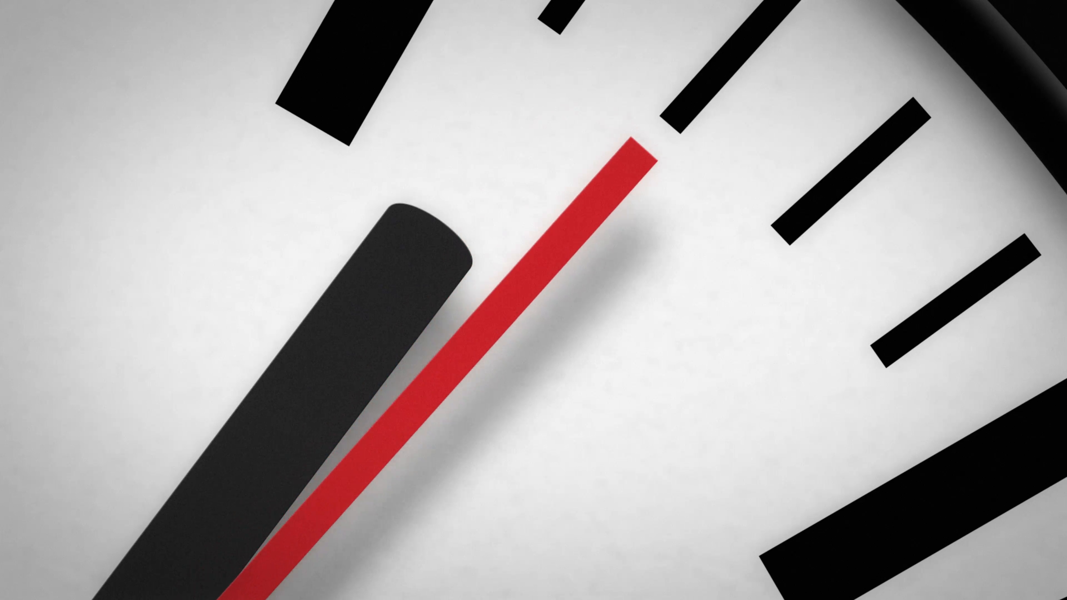

Some people suffer from aphantasia where they cannot form mental images or pictures. Most people can form mental images, however. A common illustration of perception is chronostasis or saccadic masking. This is sometimes called temporal illusion or the stopped clock illusion. The stopped clock illusion is when one perceives the second hand of an analog clock stop after first seeing it. What do we think happens? The visual system moves the eye to the target such as the second hand. The brain then extends the time of the first images typically held by the brain during the eye movement until the next event. In other words, the brain holds the second hand for fraction of time until the eye catches up with new information for it to process for one’s perception. Perception is extended over sensation creating a very brief temporal illusion.

Can you image if there were even very short gaps in our perceived vision after we moved our eyes. It would be difficult when humans are accustomed to continuity of perception. Chronostasis is how humans work, even if we do not understand it as well as we might like.

Christians need to know how their perception works as well. Paul has told us that we walk by faith and not by sight. It is by faith we guide our steps. God’s word as the source of that faith is the lamp to our feet. Faith is the underpinning of all which we hope for such as heaven and seeing God. It is the evidence or proof of what we do not see with our physical eyes (Rom 10:17, Heb 11:1). Satan is very good at making us doubt our faith though. He seeks to distort our eternal perception.

Christians are renewed in the spirit of the mind (Rom 12:2 Eph 4:23). So what should Christians hold in that space? It has to be God’s word that we are using to fill that perception space. No matter what things we might look around at in life, that perception of eternity, that sacrifice of the Christ; the love, light, and holiness of God must be held in front of our thinking. Too often I observe we let other things easily occupy that space and time in our lives. How many hours a day does your smart phone tell you have been looking at its little screen a day? How much time in front of the TV? Or on sports or ……? I want my Bible to tell me by comparison how much time I spent reading God’s word. I want to know how much time did I spend ruminating, reflecting, and meditating on God’s word? How much did I shape who I am by God’s word?

Chronostasis is an interesting mechanism the brain uses to keep one on track, but Christians need to use their minds to keep a focus on Christ and God’s word.